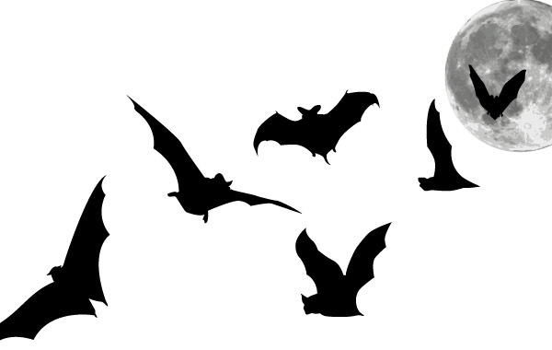
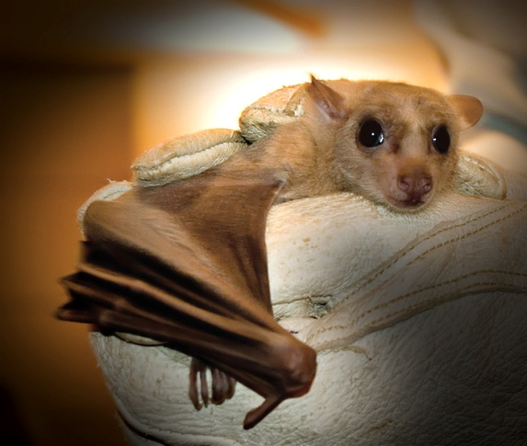

They are one of the most unique animals in the world
The only mammals that have developed flight!
Their predations of night-time insects are extremely important for the well-being of the ecosystem.
One little brown bat can eat several thousand insects each night!

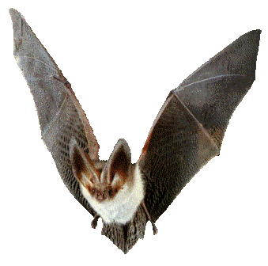
Unfortunately, due to many years of fear and misunderstanding, bat populations are decreasing and some are nearly extinct ):
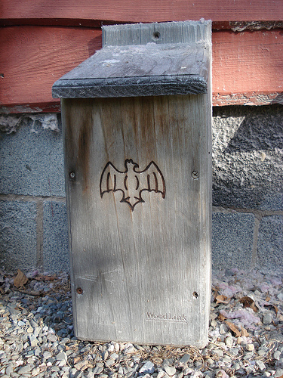
What you can do to help!
Build a bat house!
Bat houses give bats a home and keep them out of your house while their natural habitat is being destroyed
They will in turn eat thousands of your pesky insects!
They are safe - Less than 1% of bats have rabies
Learn more at http://www.batconservation.org/

