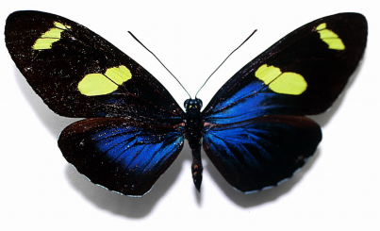
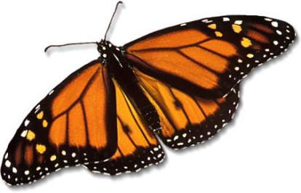
Do you want to lose your home?
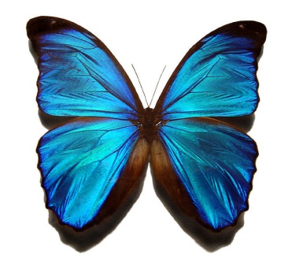
Butterflies don’t want to either, they need our help!
Not only do these creatures add color and life to a garden, but butterflies are much desired by gardeners as they help pollinate flowers. However, butterflies are losing their habitat at an alarming rate. Some causes are natural, but most are due to human activity.
Global Warming

Short life cycles and sensitive to temperature, butterflies don’t adjust to climate change well. A 35-year-long study of 159 butterfly species in 10 locations in Sierra Nevada shows an increase in average temperature has been pushing these butterfly species higher up the mountains. Once at the top, the butterflies have nowhere else to go, ending up perishing.
Need for land to cater to the needs of urbanization and increasing tourism has prompted humans to cut down forests and vegetation. Logging has further added to the problem. All this has led to the shrinking of butterfly habitat.
Loss of Habitat

With no butterflies around to pollinate a large number of crops, there would be a drastic drop in food supply for humans.
Extinction of butterflies would affect other smaller ecosystems: Monarch butterflies fly to the tropical forests of Mexico from northern parts of Canada and North America to winter. On their way back to the north, female monarch butterflies lay 300 to 400 larvae. These are eaten by other organisms, which would be in jeopardy with the disappearance of the monarch butterfly.
Prevention: trying to preserve our environment is the best option in creating a new home for these creatures. Together, we could eventually build up a butterfly garden for those who are suffering! Spread the word – help the butterflies!

